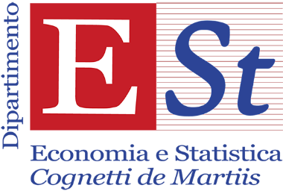

ESt & CCA SEMINAR 2020-21

Marco Giraudo
Collegio Carlo Alberto

On legal bubbles. Some thoughts on legal shockwaves at the core of the digital economy

Abstract

This article outlines the economic implications of the instability of the legal foundations of the personal-data-driven economy. For more than two decades, economic agents have been investing in the novel industry on the assumption that courts, the keepers of the legal systems, would have backed their claims, turning their technological control of personal data into legally protected property rights. Courts' backing has proved only temporary as they are now revising early solutions by constraining collection, use and trade of personal data to protect the hierarchically superior rights – e.g. privacy, lawful competition, and democratic order. This article proposes a theory of "legal bubbles" to rationalize the economics underlying the legal shockwaves affecting the personal data-driven economy. "Legal bubbles" tend to arise when economic agents invest in the economic exploitation of a new resource, in light of the rights provisionally affirmed by courts – in a context of uncertainty and ignorance about the legal implications of innovative activities. The legal foundations of the industry may eventually turn out to be unstable as a result of courts' ex-post attempt to re-adapt the legal foundations of the market to the previously ignored implications of unconstrained commodification.

June Wednesday 23rd from 12pm to 1pm
Online conference

